XXX Software Test Report

Approval List
Department/Title | Name | Signature | Date

Revision History
Revision | Date | Author | Comments

Table of Contents
1 Introduction 4
1.1 Purpose 4
1.2 Background 4
1.3 Acronyms and Abbreviations 4
1.4 References 4
2 Summary 4
2.1 Test Organization 4
2.2 Time Spent 5
2.3 Environments 5
3 Results and Analysis 5
3.1 Coverage Analysis 5
3.1.1 Requirement Coverage 5
3.1.2 Testing Coverage 5
3.2 Defects Statistic and Analysis 5
3.2.1 The statistic of defects 5
3.2.2 The analysis of defects 6
4 Conclusions and Suggestion 7
4.1 Conclusions 7
4.2 Suggestion 7
Appendix A Active Defects Table 7

- Introduction
  - Purpose
The purpose of writing this document, and specify the scope of readers.
  - Background
Brief introduction of testing project (architecture, application, system), and purpose.
Main function and performance.
Basic history and architecture.
  - Acronyms and Abbreviations
List the original definition of acronyms and abbreviations in this document.
Abbreviations (Acronyms) | Full Name
  - References
- Requirement, design, test case, manual, and other documents.
- Nation criterion, industry standard, company guideline, quality manual.
- Summary
  - Test Organization
Roles | Member
Project Manager
Test Manager
Test Designer
Test Engineer
Tester
Others
  - Time Spent
Test Type | Start Time | End Time | Work hours
Total
  - Environments
Environments include the equipments and the network topology which were used in test.
- Results and Analysis
  - Coverage Analysis

Requirement Coverage
Requirement coverage indicates the rate of function have been test to function requirement, which must be 100%.

Testing Coverage
Test Type | Number of test Cases which were passed | Number of test Cases which were failed | Number of test Cases which were untested | Total Number
Total
Coverage Rate=(Been run/All test cases)*100%
  - Defects Statistic and Analysis

The statistic of defects
In this table, the column of “Closed” shows the previous defects which were closed in present version, and the other columns show the present version’s defects status, so this table can not be created by TD directly.
 | Closed | Fixed | New | Open | Reopen | Suspend | <total>
A-Critical
B-Major
C-Minor
D-Warning
E-Suggestion
<total>

The analysis of defects
- The analysis of defects severity.
This graph shows the severity percents in all of the new detected defects, it's generated by TD directly (Except status of "closed" and "rejected").
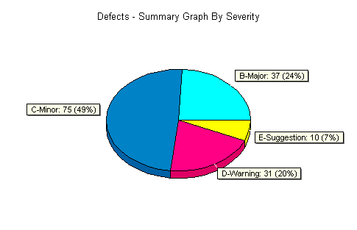
- The analysis of defects progress (X-Axis is date; Y-Axis is the number of defects.).
Cut line of Defects: trend of daily or weekly Defects amount, and generate by TD. In this graph, the status of "closed" and "rejected" were not included (use filter), and the total line should be showed.
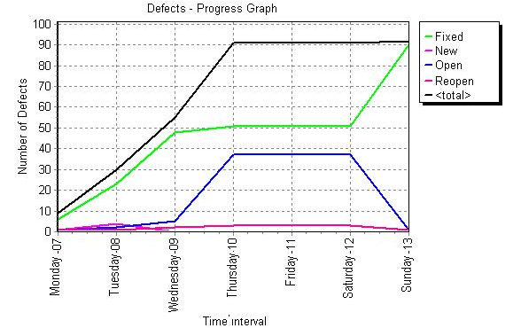
- Conclusions and Suggestion
  - Conclusions
- If perform test sufficiently or not
- Control measure and effect to testing risk
- If testing target has been completed or not
- If testing has been passed or not
- If enter the next target or not
  - Suggestion
- Explain the problems system has; description the shortage of testing tool has been met during test, and probable effect of software to implement
- Probable latent Defects and later work
- Suggestion to Defects resolve and production design
- Suggestion to process improve

Appendix A Active Defects Table
List all active(Include "open", "Reopen","Fixed" status in present version) defects which severity are minor or above, and can use "Save As…" function in TD to make this table.
Defect ID | Severity | Summary | Description

